**40 FROM BASE 8 TO BASE 2:**

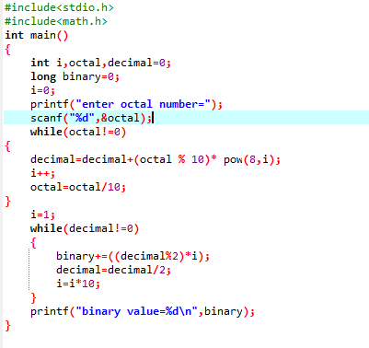

**OUTPUT**

